**Lesson02 Diff between PowerShell and Azure CLI**

**Notes: -**

**1-Powershell is framework that works on various Microsoft services**

**(its not for Azure , can used for office 365,for your windows machine as well)**

**2-Azure CLI is working only for Azure**

**Provide Azure Package on Windows PowerShell**

**Steps:-**

**1-run windows powershell as administrator**

**2-on powershell execute the following commands**

**//provide remote signed policy on powershell**

**Set-ExecutionPolicy RemoteSigned**

**//to install the Azure package on powershell on current user**

**Install-Module -Name Az -AllowClobber -Scope CurrentUser**

**//to install teh Azure Module**

**Import-Module Az -Verbose**

**//to connect to azure account**

**Az login**

**//to get the resource group on the specific location**

**Az group list**

**Azure Concepts**

**Notes:-**

**1-Azure Subscription: this is way of billing on how much you use in Azure**

**2-Azure Active Directory: this is identity store which you can set roles for users to access to subscription and resource groups and also resources etc...**

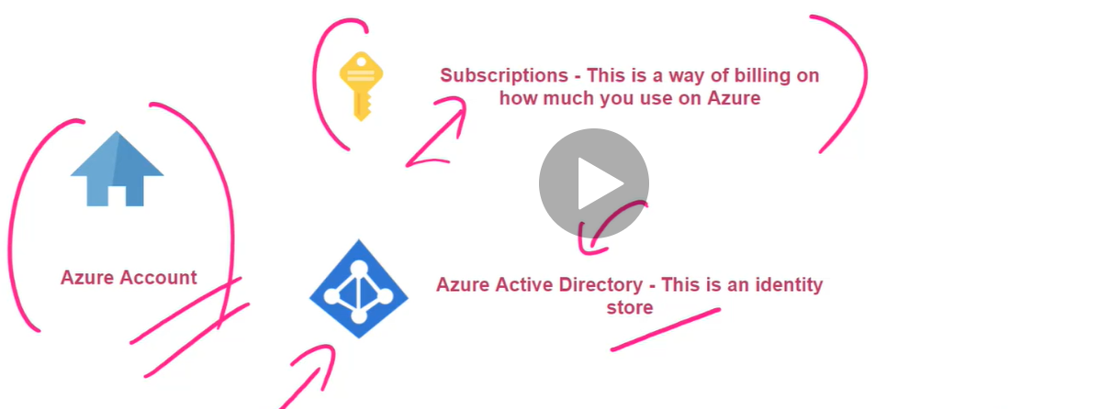

**3-you can assign resources into the resource group (with assign region to it as below)**

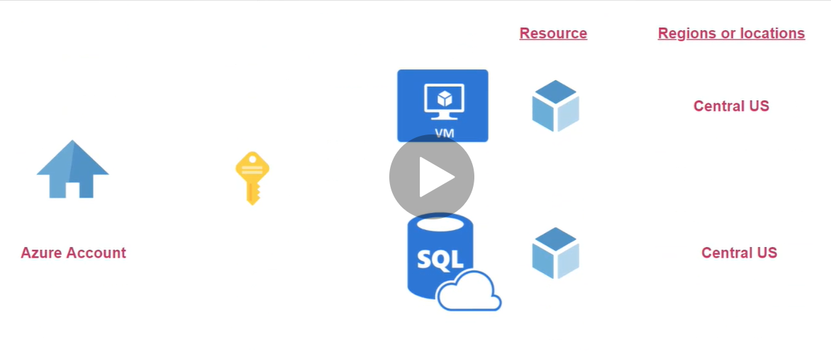

**(You can assign resources to the resource group as below)**

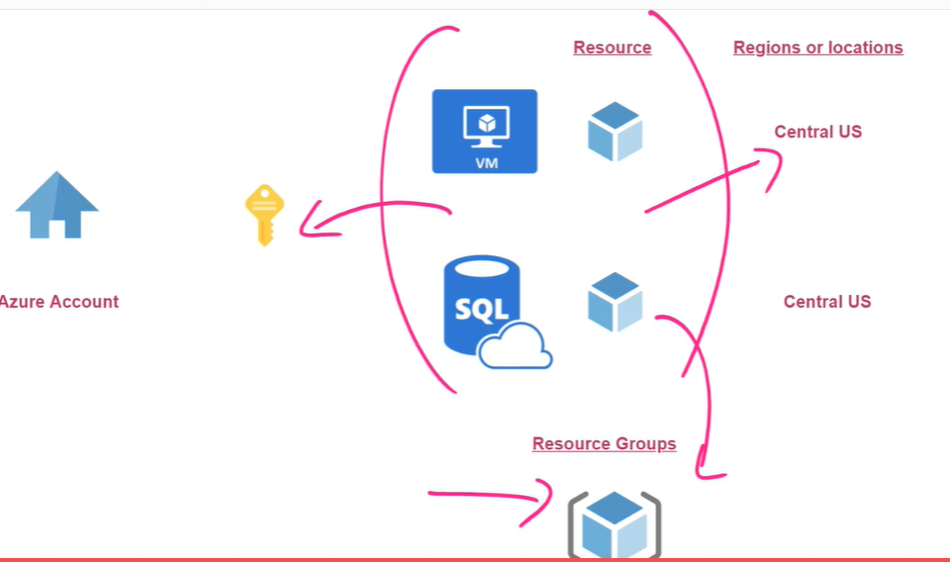

**4-you can search on the product on the link below and see if the services as available on the region you want** [Azure Products by Region | Microsoft Azure](https://azure.microsoft.com/en-us/global-infrastructure/services/)

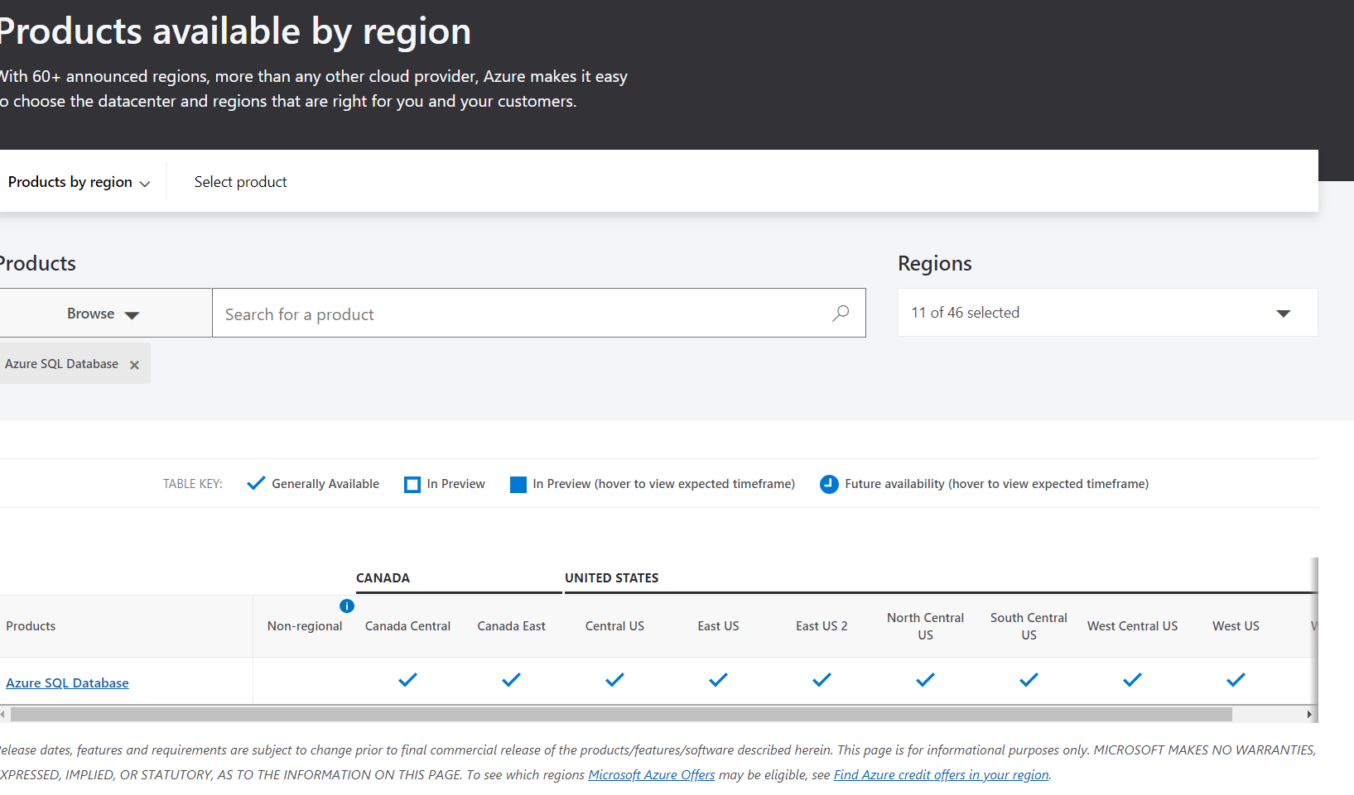

**5-you can see the subscription costing by setting on search subscription and you see current cost**

